20BCS042 MOHD ADIL OS LAB EXAM

Write a program to implement the First Come First Serve scheduling algorithm and find the average turnaround time, waiting time, completion time and response time for overall process. Also Print Gantt chart for it.

//FCFS   
   
#include<iostream>   
using namespace std;   
   
int n;   
float avgCt, avgWt, avgTt;   
   
struct Process{   
 char Pname[5];   
   
 int arvlTime;   
 int brstTime   
 int cmpTime;   
 int wtngTime   
 int tatTime;   
   
 struct Process *next;   
};   
   
int isEmpty(Process *front){   
 if(front==NULL || n==0){   
 return 1;   
 }   
 return 0;   
}   
   
struct Process *insert(Process *front, int i){   
   
 struct Process *p = (struct Process*)malloc(sizeof(struct Process));   
   
 cout<<"Enter the name of the Process "<<i<<", its Burst and Arrival Time :   
";   
 cin>>p->Pname>>p->brstTime>>p->arvlTime;

1. p->next = NULL;   
      
    if(front==NULL){   
    front = p;   
    }   
      
    else if (front->arvlTime > p->arvlTime){   
    p->next = front;   
    front = p;   
    }   
      
    else{   
      
    struct Process *tmp = front;   
    while (tmp->next != NULL && tmp->next->arvlTime < p->arvlTime){   
    tmp = tmp->next;   
    }   
      
    p->next = tmp->next;   
    tmp->next = p;   
    }   
      
    return front;   
   }   
      
   void calculate(Process *front){   
    if(isEmpty(front)){   
    cout<<"\nNo processes in the ready Queue";   
    return;   
    }   
    front->wtngTime=0;   
    front->cmpTime=front->brstTime;   
      
    //calculating completion time   
    int prv = front->cmpTime;   
    struct Process *tmp = front->next;   
    while(tmp!=NULL){   
    tmp->cmpTime = prv + tmp->brstTime;   
    prv = tmp->cmpTime;   
    tmp=tmp->next;   
    }   
      
    //calculating waiting time   
    prv = front->cmpTime;   
    tmp = front->next;   
    while(tmp!=NULL){
2. tmp->wtngTime = prv - tmp->arvlTime;   
    prv = tmp->cmpTime;   
    tmp=tmp->next;   
    }   
      
    //calculating turn arround time   
    tmp = front;   
    while(tmp!=NULL){   
    tmp->tatTime = tmp->wtngTime + tmp->brstTime;   
    tmp=tmp->next;   
    }   
      
    //calculating average time   
    tmp = front;   
    float s1=0, s2=0, s3=0;   
    while(tmp!=NULL){   
    s1 = s1 + tmp->cmpTime;   
    s2 = s2 + tmp->wtngTime;   
    s3 = s3 + tmp->tatTime;   
    tmp=tmp->next;   
    }   
      
    avgCt = s1/n;   
    avgWt = s2/n;   
    avgTt = s3/n;   
   }   
      
   void display(Process *front){   
    if(isEmpty(front)){   
    cout<<"\nNo processes in the ready Queue";   
    return;   
    }   
      
    cout<<"\n\nDisplaying the table :- ";   
      
    struct Process *tmp = front;   
      
    cout<<"\n\n+--------------+------------+--------------+-----------------+--  
   ------------+-----------------+---------------+";   
    cout<<"\n| Process name | Burst Time | Arrival Time | Completion Time |   
   Waiting Time | TurnAround Time | Response Time |";   
    cout<<"\n+--------------+------------+--------------+-----------------+----  
   ----------+-----------------+---------------+";   
      
    while(tmp!=NULL){   
    printf("\n| %s | %2d | %2d | %2d   
    | %2d | %2d | %2d |"
3. ,tmp->Pname, tmp->brstTime, tmp->arvlTime, tmp->cmpTime, tmp-  
   >wtngTime, tmp->tatTime, tmp->wtngTime);   
    cout<<"\n+--------------+------------+--------------+-----------------+----  
   ----------+-----------------+---------------+";   
    tmp=tmp->next;   
    }   
      
    cout<<"\n\n";   
    printf("\nAverage Completion time : %.2fns", avgCt);   
    printf("\nAverage Waiting time : %.2fns", avgWt);   
    printf("\nAverage TurnAround time : %.2fns", avgTt);   
    printf("\nAverage Response time : %.2fns", avgWt);   
   }   
      
   void printGanttChart(Process *front){   
    if(isEmpty(front)){   
    cout<<"\nNo processes in the ready Queue";   
    return;   
    }   
      
    cout<<"\n\nGantt Chart : ";   
      
    struct Process *tmp = front;   
      
    cout<<"\n\n+";   
    while(tmp!=NULL){   
    for(int i=0; i<2*tmp->brstTime; i++){   
    cout<<"-";   
    }   
    cout<<"+";   
    tmp = tmp->next;   
    }   
      
    tmp = front;   
    cout<<"\n|";   
    while(tmp!=NULL){   
    for(int i=0; i<tmp->brstTime-1; i++){   
    cout<<" ";   
    }   
    cout<<tmp->Pname;   
    for(int i=0; i<tmp->brstTime-1; i++){   
    cout<<" ";   
    }   
    cout<<"|";   
    tmp = tmp->next;   
    }
4. tmp = front;   
    cout<<"\n+";   
    while(tmp!=NULL){   
    for(int i=0; i<2*tmp->brstTime; i++){   
    cout<<"-";   
    }   
    cout<<"+";   
    tmp = tmp->next;   
    }   
      
    tmp = front;   
    cout<<"\n0";   
    while(tmp!=NULL){   
    for(int i=0; i<2*tmp->brstTime-1; i++){   
    cout<<" ";   
    }   
    // cout<<tmp->cmpTime;   
    printf("%2d", tmp->cmpTime);   
    tmp = tmp->next;   
    }   
    cout<<"\n\n";   
   }   
      
   int main(){   
    cout<<"\nName : Mohd Adil";   
    cout<<"\nRoll No : 20BCS042";   
      
    cout<<"\nEnter the number of process";   
    cin>>n;   
      
    struct Process *front = NULL;   
      
    for(int i=1; i<=n; i++){   
    front = insert(front,i);   
    }   
      
    calculate(front);   
    display(front);   
    printGanttChart(front);   
   return 0;   
   }

OUTPUT:

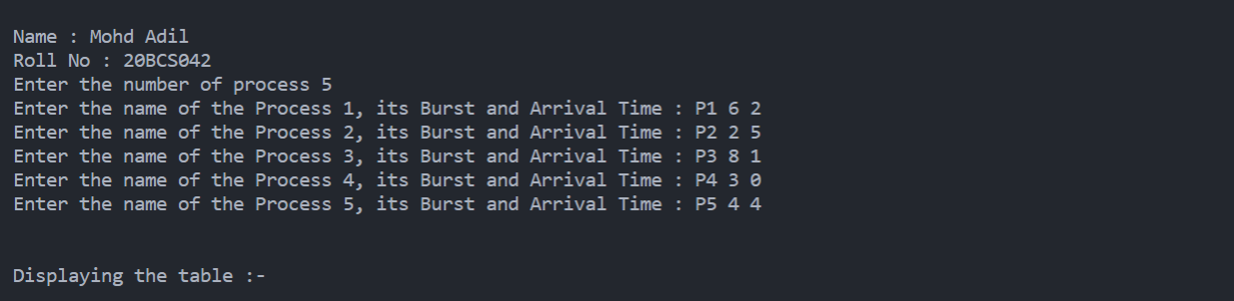

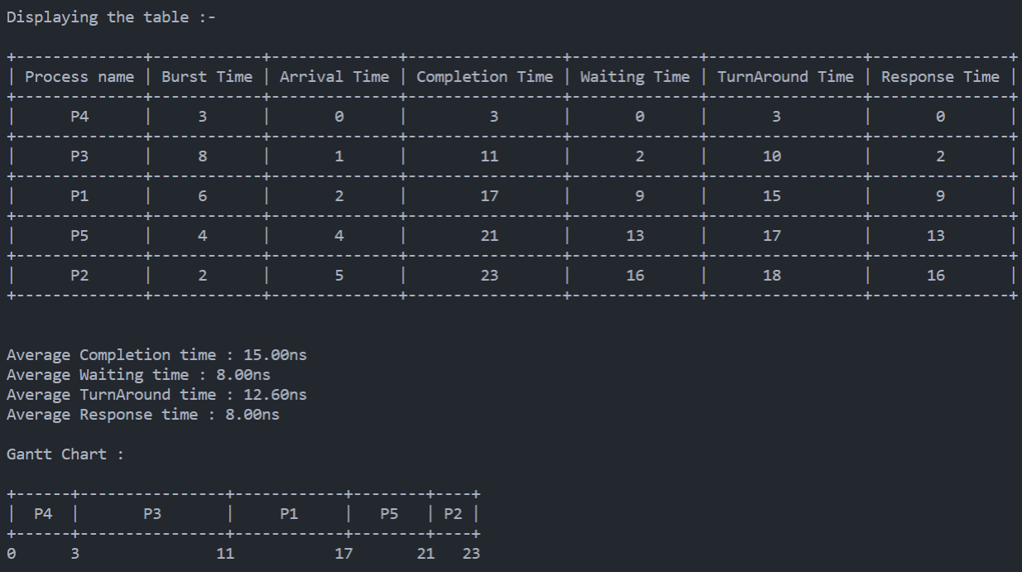

Write a program to implement the Best fit memory management algorithm. Program should take input total no. of memory block, their sizes, process name and process size. Output of program should give the details about memory allocated to process with fragmentation detail.

#include <iostream>

#include <vector>

using namespace std;

struct Process

{

    char Pname[3];

    int memory;

    bool allocated = false;

};

struct Block

{

    int size;

    bool used = false;

    int rem;

    struct Process processAllocated;

};

int main()

{

    cout << "No. of block : ";

    int n;

    cin >> n;

    vector<Block> blocks;

    cout << "Enter Size of the " << n << " Blocks: ";

    for (int i = 0; i < n; i++)

    {

        Block tempBlock;

        cin >> tempBlock.size;

        tempBlock.rem = tempBlock.size;

        blocks.push_back(tempBlock);

    }

    cout << "No. of Process : ";

    int m;

    cin >> m;

    vector<Process> Processes;

    cout << "Enter Name and size of the Processes: ";

    for (int i = 0; i < m; i++)

    {

        Process tempProcess;

        cin >> tempProcess.Pname;

        cin >> tempProcess.memory;

        Processes.push_back(tempProcess);

    }

    // memory allocation

    for (int i = 0; i < m; i++)

    {

        bool exist = false;

        int index, min = INT16_MAX;

        for (int j = 0; j < n; j++)

        {

            if (Processes[i].memory <= blocks[j].rem && blocks[j].used == false && blocks[j].rem < min)

            {

                min = blocks[j].rem;

                exist = true;

                index = j;

            }

        }

        if (exist)

        {

            Processes[i].allocated = true;

            blocks[index].used = true;

            blocks[index].rem = blocks[index].size - Processes[i].memory;

            blocks[index].processAllocated = Processes[i];

        }

    }

    cout << "\tBlock Number\tSize\tProcess Allocated\tInternal Fragmentation" << endl;

    for (int i = 0; i < n; i++)

    {

        if (blocks[i].used == true)

        {

            cout << "\t\t" << i + 1 << "\t" << blocks[i].size << "\t\t" << blocks[i].processAllocated.Pname << "\t\t\t" << blocks[i].rem << endl;

        }

        else

        {

            cout << "\t\t" << i + 1 << "\t" << blocks[i].size << "\t\t"

                 << "---"

                 << "\t\t\t"

                 << "---" << endl;

        }

    }

    bool flag = true;

    int remProcessesSize = 0;

    for (int i = 0; i < m; i++)

    {

        if (Processes[i].allocated == false)

        {

            flag = false;

            remProcessesSize += Processes[i].memory;

        }

    }

    int IF = 0, EF = 0;

    for (int i = 0; i < n; i++)

    {

        if (blocks[i].used == true)

        {

            IF += blocks[i].rem;

        }

        else

        {

            if (flag == false)

            {

                EF += blocks[i].rem;

            }

        }

    }

    if (EF <= remProcessesSize)

    {

        EF = 0;

    }

    cout << "Total Internal Fragmentation = " << IF << endl;

    cout << "Total External Fragmentation = " << EF << endl;

    return 0;

}

OUTPUT:

